

FACULTYOFINFORMATION& COMMUNICATION TECHNOLOGY

SEMESTER 1 SESSION 2020/2021

BITI3533 ARTIFICIAL INTELIGENCE PROJECT MANAGEMENT

FIRE DETECTION USING COMPUTER VISION

WBS - THE PROJECT SCOPE STATEMENT AND PROJECT

MANAGEMENT PLAN

Prepared for:

PROF. TS. DR. GOH ONG SING

Prepared by:

|  |  |  |
| --- | --- | --- |
| **NAME** | **MATRIC NO.** | **PROGRAMME** |
| NUR’AIN NAJIHA BINTI ZAKARIA | B031910466 | BITI |
| NUR IZZATI BINTI SHAFIE | B031910476 | BITI |
| MEGALA D/O SONTULOM | B031910172 | BITI |

12rd NOVEMBER 2020

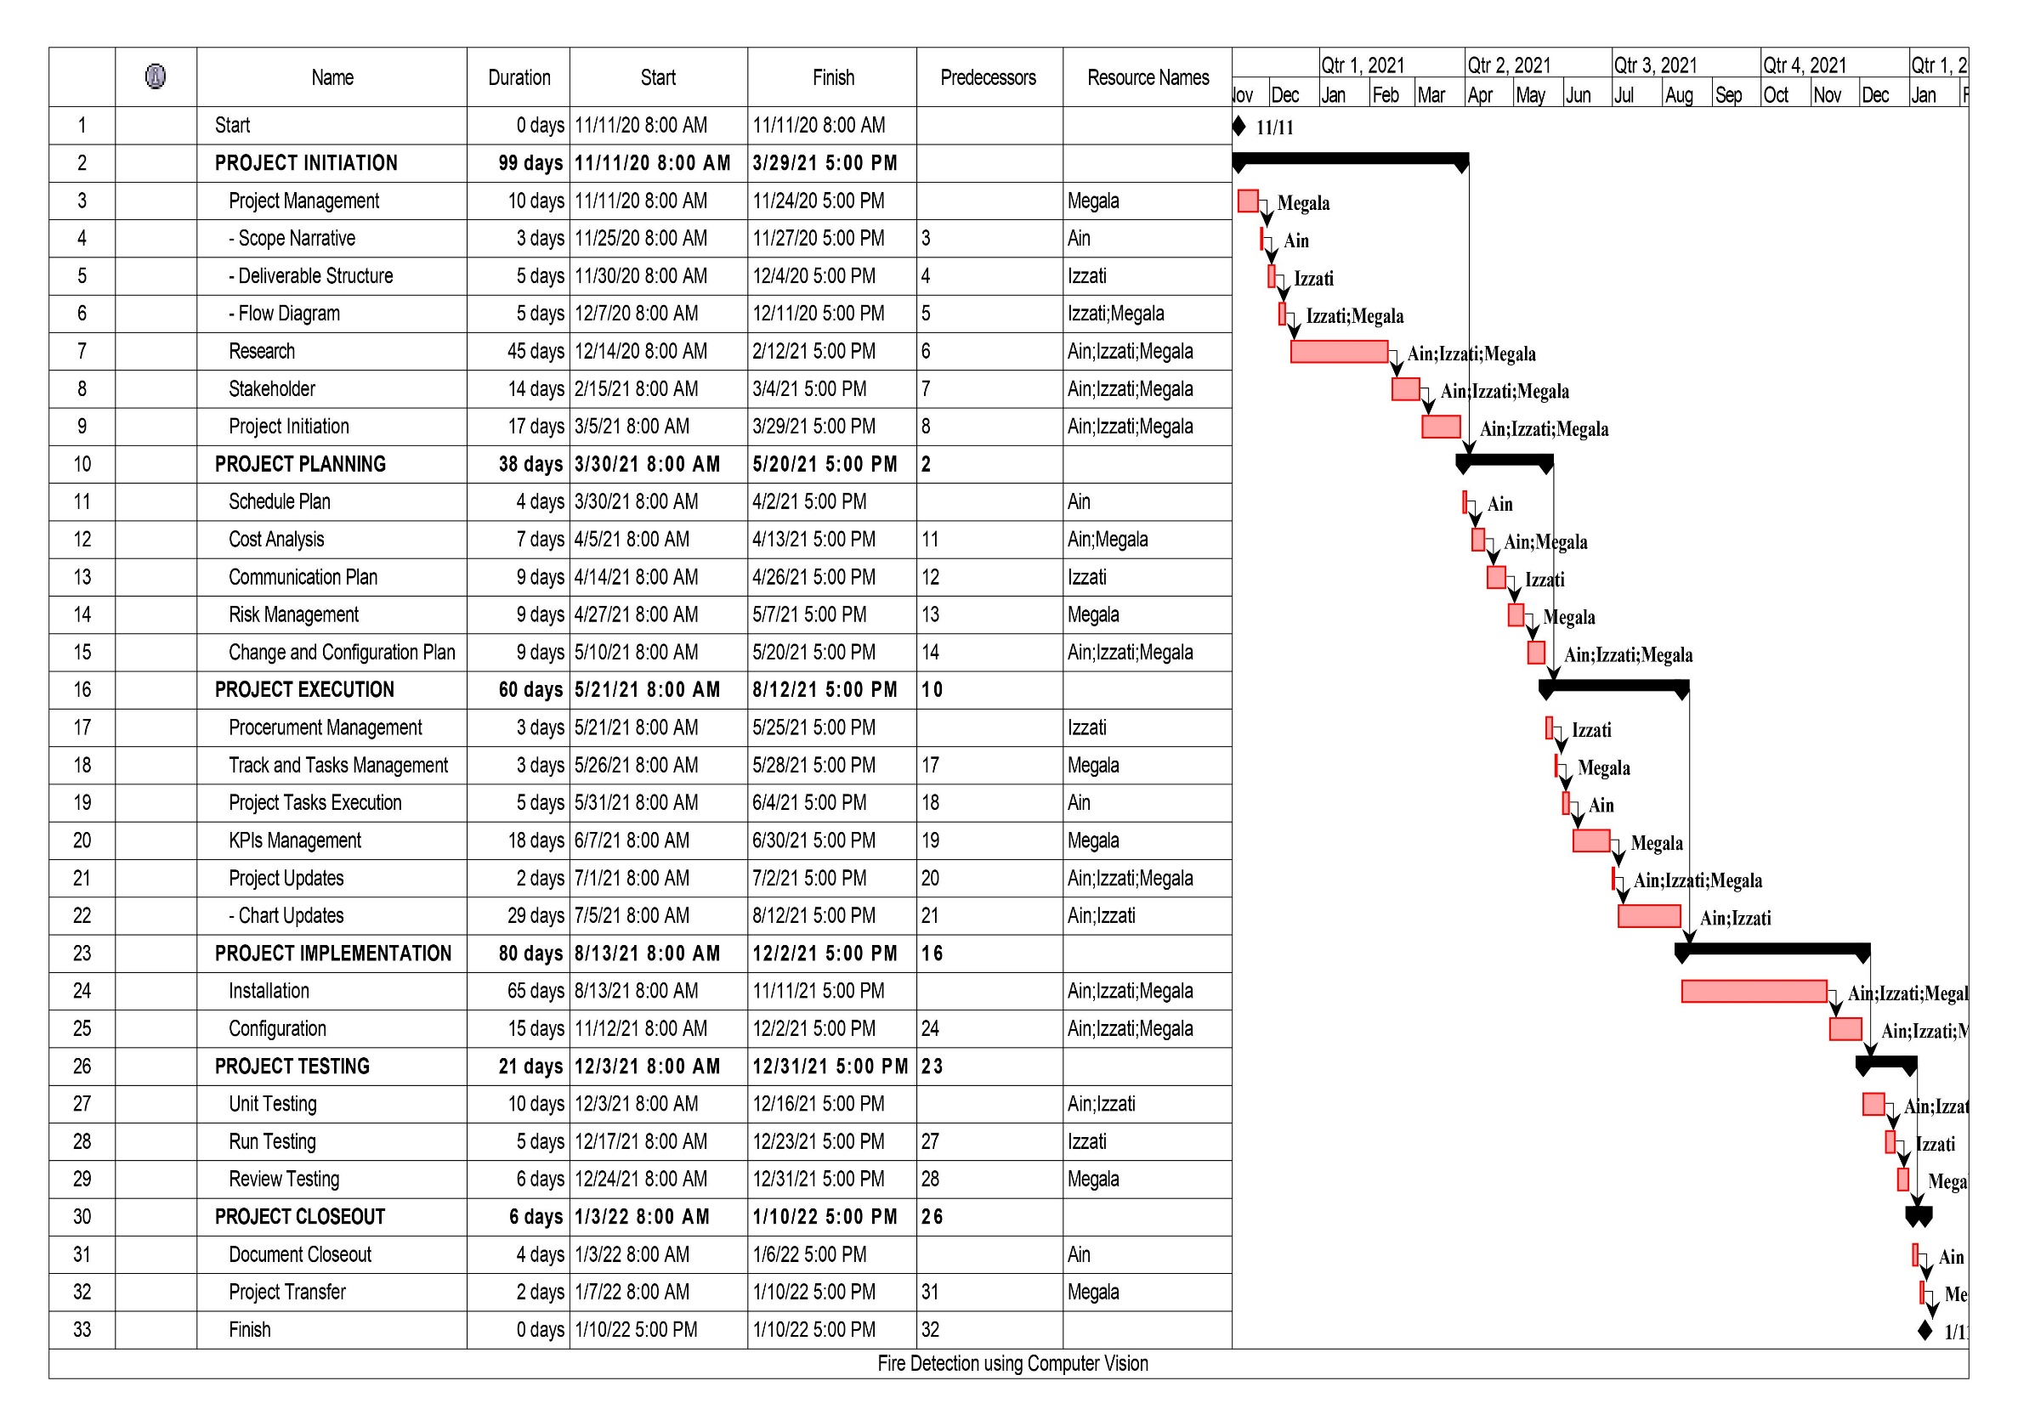

**Figure 1** WBS using ProjectLibre